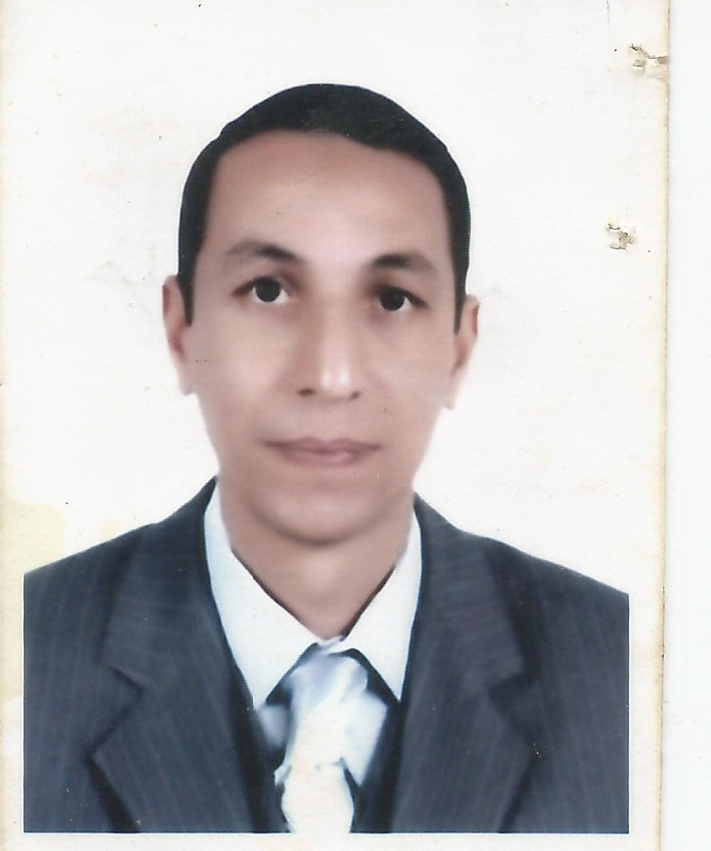

CURRICULUM VITAE (C.V.)

Personal data:

Name : Dr./ Khaled Ahmed Sayed
Date of birth : 1/4/1970
Place of birth : Abnoub - Assiut

Nationality : Egyptian
Marital status : Married and have 3 children
Current Occupation : Lecturer of Infectious diseases,
Faculty of Veterinary Medicine, Assiut
University, Assiut, Egypt
Tel. 01141721104
01003489735
E.mail: khaledsayed_1970@yahoo.com

Educational qualifications:
1. Bachelor of Veterinary Science (B.V.Sc), from Faculty of Vet. Med., Assiut,
University, Assiut, Egypt, May, 1993, with Very good with honor.
2. Master of Veterinary Science (M.V.Sc), from Faculty of Vet. Med., Assiut
University, Assiut, Egypt, 2001.
3. Philosophy Doctor of Veterinary Science (PhD. V. Sc.), from Faculty of Veterinary Medicine, Assiut University, Assiut, Egypt, 2006.

Professional experience:
- Teaching of infectious diseases for undergraduate students.
-Teaching of infectious diseases for postgraduate students (Diploma - Master –
PhD students).
- Supervision of scientific thesis in the field of specialization (Master – PhD students).
- Participation in seminars and training courses and workshops are set up by the college in the Assiut University.
- Participation in the organization of conferences held by the college.
- Participation in convoys' survey carried out by the veterinary college in the villages of Upper Egypt, such as (Assiut - Fayoum ).
- To diagnose and treat the infectious diseases in the Teaching Hospital, Faculty of Veterinary Medicine - Assiut University.

Scientific Societies:
1. Member in the Egyptian Society for Cattle diseases, Assiut University.
2. Member in the Society for Camel diseases and health, Assiut University.

Courses and professional expertise within the University of Assiut and abroad:
- Attended a training course on" Lab quality assurance ISO 17025", which was held in the period from 8-12/11/2009 - at the Animal Health Research Institute- Dokky .
- Attended a workshop on "Verification of Avian Influenza Vaccines" which was held in the period from 26-28/7/2010 at Luxor by the Animal Health Research Institute.
- Attended a training course "new applications for PCR" in the period from 18-20/3/2013 which was held at the Genetic Engineering and Molecular Biology Research Center- Assiut University.
- Attended a training course "New Techniques in Molecular Biology as well as Principles and Application of DNA Sequencing"in the period from 25-27/3/2013 which was held at the Genetic Engineering and Molecular Biology Research Center- Assiut University.
- Attended a training course " From Gene to Protein "in the period from 31/3/2014-2/4/2014 which was held at the Genetic Engineering and Molecular Biology Research Center- Assiut University.
- Attended a workshop on "Basic techniques in animal cell tissue culture" which was held at the Zoology Department – Faculty of Science - Assiut University.
- Attended the FLDC training courses entitled :
"Code of Ethics" – "Legal and Financial aspects in university environment" – "Credit hour system" – "Effective presentation" – "Quality standards in teaching 1" – "Student evaluation"
- ICDL certificate.
Scientific activity within the University of Assiut and abroad: -
The work of teaching:
- Teaching of practical lessons and theoretical material of infectious diseases for
Undergraduate students, in Assiut University.
- Working for teaching and supervision of practical and theoretical lessons of infectious diseases on postgraduate students (Diploma – MS- PhD).
- Supervision on the diagnosis and treatment of infectious diseases in Teaching Hospital, Faculty of Veterinary Medicine - Assiut University.

Conferences:-
- Participation in the 7th Scientific Conference of the Egyptian Society for cattle diseases, which was held at the Faculty of Veterinary Medicine, Assiut University, Egypt - in the period from 7-9/12/2003.
- Participation (with article) in the 13th Scientific Conference of the Faculty of Veterinary Medicine, Assiut University, Egypt - in the period from 23-25/11/2008.
- Participation in the 10th Scientific Conference of the Egyptian Society for cattle diseases, which was held at the Faculty of Veterinary Medicine, Assiut University, Egypt - in the period from 13-15/12/2009.
- Participation in the 15th Scientific Conference of the Faculty of Veterinary Medicine, Assiut University, Egypt - 2012.
- Participation (with article) in the 16th Scientific Conference of the Faculty of Veterinary Medicine, Assiut University, Egypt – 30/11-2/12/2014.

List of Publications:
- EL-Khabaz, Kh. A.S.; Malek, Safaa S. and Hussein, H.A. (2015): Bacteriological, cytological, and hematological changes associated the ovine subclinical mastitis. Assiut Vet. Med. J. Vol. 61 No. 145 (236-241 )
- Hussein, H.A.; EL-Khabaz, Kh. A.S. and Malek, Safaa S. (2015): Is udder ultrasonography a diagnostic tool for subclinical mastitis in sheep?. Small Ruminant Research. DOI:10.1016/j.smallrumres.2015.05.010

- EL-Khabaz, Kh. A.S. (2014): Rapid laboratory diagnosis of lumpy skin disease by using PCR technique. Assiut Vet. Med. J. Vol. 60 No. 143, 37-41.

4. EL Berbawy, S.M. and EL-Khabaz, Kh. A.S. (2014): Chlamydia infection in aborted and clinically healthy ewes in Assiut governorate using microscopical examination and ELISA. Assiut Vet. Med. J. Vol. 60 No. 142: (23-28).
- EL-Khabaz, Kh. A.S. and Arafa, M.I. (2014): Study on the prevalence of internal parasitic infection in diarrheic and apparently healthy sheep at Assiut governorate, Egypt. Zagazig Vet. J. Vol. 42 No. 3 (157-168)
- EL-Khabaz, Kh. A.S. and Arafa, M.I. (2014): Prevalence of Coccidial infection in diarrheic and clinically healthy sheep in Assiut governorate, Egypt. The 16th Scientific Congress. 30th Nov. – 2nd Dec. 2014. Faculty of Vet. Med. Assiut University. Egypt. Pp 81 – 89
7 . EL-Khabaz, Kh. A.S.; Hussien, M.F.; Abd-EL Naser, Eman M. and Ahmed, Hanaa A. (2011): Studying the occurrence of clumping factor gene in Staph aureus isolated from cases of subclinical mastitis and the effect of such pathogen on milk composition. Assiut Vet. Med. J. Vol. 57 No. 129: (78 - 94)

8 . Abd-EL Naser, Eman M. ; Hussien, M.F. and EL-Khabaz, Kh. A.S. (2010): Some bacteriological studies on subclinical mastitis in cattle and its relation to changes in the milk protein electrophoretic pattern. Assiut Vet. Med. J. Vol. 56 No. 127 ( 58 - 74 )

9. Hussien, M.F. and EL-Khabaz, Kh. A.S. (2008): PCR as a confirmatory method for identification of Bacillus cereus enterotoxigenic strain isolated from flavored milk. Zagazig Vet. J. Vol. 36. No. 5: 69- 76

10. Abd El-Malek, A. M. and EL-Khabaz, Kh.A.S. (2008): Using polymerase chain reaction (PCR) in the identification of B. cereus isolated from ready-to- eat El-hawawshy sandwiches in Assiut city. 13th Scientific Congress. 23-25 November ( 2008 ) Faculty of Vet. Med. Assiut University. Egypt. pp 113-125.

